|  |
| --- |
| Cybersecurity |
| Penetration Test Report |

Rekall Corporation

Penetration Test Report

**Student Note: Complete all sections highlighted in yellow.**

# 

## Confidentiality Statement

This document contains confidential and privileged information from Rekall Inc. (henceforth known as Rekall). The information contained in this document is confidential and may constitute inside or non-public information under international, federal, or state laws. Unauthorized forwarding, printing, copying, distribution, or use of such information is strictly prohibited and may be unlawful. If you are not the intended recipient, be aware that any disclosure, copying, or distribution of this document or its parts is prohibited.

Table of Contents

Confidentiality Statement 2

Contact Information 4

Document History 4

Introduction 5

Assessment Objective 5

Penetration Testing Methodology 6

Reconnaissance 6

Identification of Vulnerabilities and Services 6

Vulnerability Exploitation 6

Reporting 6

Scope 7

Executive Summary of Findings 8

Grading Methodology 8

Summary of Strengths 9

Summary of Weaknesses 9

Executive Summary Narrative 10

Summary Vulnerability Overview 13

Vulnerability Findings 14

# 

## Contact Information

|  |  |
| --- | --- |
| **Company Name** | Solid Shield Cybersecurity |
| **Contact Name** | Adrian Davy |
| **Contact Title** | Penetration Tester |

## 

## Document History

|  |  |  |  |
| --- | --- | --- | --- |
| **Version** | **Date** | **Author(s)** | **Comments** |
| 001 | 03/11/2022 | Adrian Davy |  |

# 

## Introduction

In accordance with Rekall policies, Solid Shield Cybersecurity organization conducts external and internal penetration tests of its networks and systems throughout the year. The purpose of this engagement was to assess the networks’ and systems’ security and identify potential security flaws by utilizing industry-accepted testing methodology and best practices.

For the testing, Solid Shield Cybersecurity focused on the following:

* Attempting to determine what system-level vulnerabilities could be discovered and exploited with no prior knowledge of the environment or notification to administrators.
* Attempting to exploit vulnerabilities found and access confidential information that may be stored on systems.
* Documenting and reporting on all findings.

All tests took into consideration the actual business processes implemented by the systems and their potential threats; therefore, the results of this assessment reflect a realistic picture of the actual exposure levels to online hackers. This document contains the results of that assessment.

### Assessment Objective

The primary goal of this assessment was to provide an analysis of security flaws present in Rekall’s web applications, networks, and systems. This assessment was conducted to identify exploitable vulnerabilities and provide actionable recommendations on how to remediate the vulnerabilities to provide a greater level of security for the environment.

Solid Shield Cybersecurity used our proven vulnerability testing methodology to assess all relevant web applications, networks, and systems in scope.

Rekall has outlined the following objectives:

Table 1: Defined Objectives

|  |
| --- |
| **Objective** |
| Find and exfiltrate any sensitive information within the domain. |
| Escalate privileges. |
| Compromise several machines. |

# 

## Penetration Testing Methodology

### Reconnaissance

### 

Solid Shield Cybersecurity begin assessments by checking for any passive (open source) data that may assist the assessors with their tasks. If internal, the assessment team will perform active recon using tools such as Nmap and Bloodhound.

### Identification of Vulnerabilities and Services

Solid Shield Cybersecurity use custom, private, and public tools such as Metasploit, hashcat, and Nmap to gain perspective of the network security from a hacker’s point of view. These methods provide Rekall with an understanding of the risks that threaten its information, and also the strengths and weaknesses of the current controls protecting those systems. The results were achieved by mapping the network architecture, identifying hosts and services, enumerating network and system-level vulnerabilities, attempting to discover unexpected hosts within the environment, and eliminating false positives that might have arisen from scanning.

### Vulnerability Exploitation

Solid Shield Cybersecurity normal process is to both manually test each identified vulnerability and use automated tools to exploit these issues. Exploitation of a vulnerability is defined as any action we perform that gives us unauthorized access to the system or the sensitive data.

### Reporting

Once exploitation is completed and the assessors have completed their objectives, or have done everything possible within the allotted time, the assessment team writes the report, which is the final deliverable to the customer.

# 

## Scope

Prior to any assessment activities, Rekall and the assessment team will identify targeted systems with a defined range or list of network IP addresses. The assessment team will work directly with the Rekall POC to determine which network ranges are in-scope for the scheduled assessment.

It is Rekall’s responsibility to ensure that IP addresses identified as in-scope are actually controlled by Rekall and are hosted in Rekall-owned facilities (i.e., are not hosted by an external organization). In-scope and excluded IP addresses and ranges are listed below.

# 

# 

## Executive Summary of Findings

## 

### Grading Methodology

Each finding was classified according to its severity, reflecting the risk each such vulnerability may pose to the business processes implemented by the application, based on the following criteria:

**Critical**: Immediate threat to key business processes.

**High**: Indirect threat to key business processes/threat to secondary business processes.

**Medium**: Indirect or partial threat to business processes.

**Low**: No direct threat exists; vulnerability may be leveraged with other vulnerabilities.

Informational: No threat; however, it is data that may be used in a future attack.

As the following grid shows, each threat is assessed in terms of both its potential impact on the business and the likelihood of exploitation:

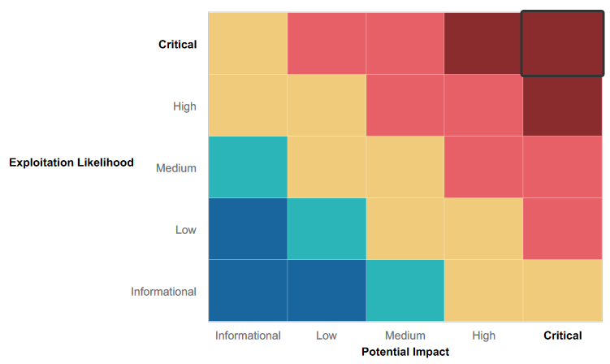

### 

### Summary of Strengths

While the assessment team was successful in finding several vulnerabilities, the team also recognized several strengths within Rekall’s environment. These positives highlight the effective countermeasures and defenses that successfully prevented, detected, or denied an attack technique or tactic from occurring.

* Mitigation strategy in place for denial of DDOS Attacks to ensure network availability.
* Required authentication to host in place, restricting access to the network
* Utilization of trusted certificate authority and SSL/HTTPS to harden website security
* Multiple servers in place to prevent single source failure and single source access.
* Mitigation strategy in place for denial of DDOS attacks to ensure network availability.

### Summary of Weaknesses

We successfully found several critical vulnerabilities that should be immediately addressed in order to prevent an adversary from compromising the network. These findings are not specific to a software version but are more general and systemic vulnerabilities.

* Web application is vulnerable to XSS and SQL injection attacks
* Credentials are stored in HTML source code, making them easily accessible
* Apache web server is outdated and vulnerable to multiple exploits
* SLMail server is vulnerable to exploits that allow access to the shell
* Unauthorized access to password hashes allows for password cracking and privilege escalation
* Rekall Server's physical address is publicly available
* Credentials are displayed when performing an IP lookup
* IP addresses within Rekall's range display potential vulnerabilities (open ports, IP addresses, etc.) when scanned
* Open ports allow for file enumeration and unauthorized access

## Executive Summary

Solid Shield Cybersecurity conducted a comprehensive security assessment on Rekall to determine existing vulnerabilities and assess the current level of security risk associated with the company's network and technologies. The assessment used penetration testing and ethical hacking techniques to provide Rekall management with an understanding of the risks and security posture of their network environment.

TEST SCOPE

The test scope for this engagement included eight hosts on Rekall's internal network and five open ports.

Testing was performed using industry-standard tools and frameworks such as Nmap, zenmap, whatweb, nslookup, the Metasploit Framework, WPScan, Burp Suite, lsadump, Aircrack-ng, Nessus, and john the ripper.

The testing was able to successfully perform cross-site scripting on Rekall's official website, exposing sensitive data within the HTTP header and on the login page using Burp suite. The testing also revealed confidential credentials to log in as Administrator, and was able to execute local file inclusion onto the website, uploading malicious files and scripts. The testing obtained the robot.txt page to uncover hidden directories and files, and was able to run terminal commands on the site to display sensitive data and information such as login credentials, unauthorized directories and files. The testing used brute force to successfully login as a user, and performed directory traversal and multiple injections on the website to execute malicious code that was successfully executed.

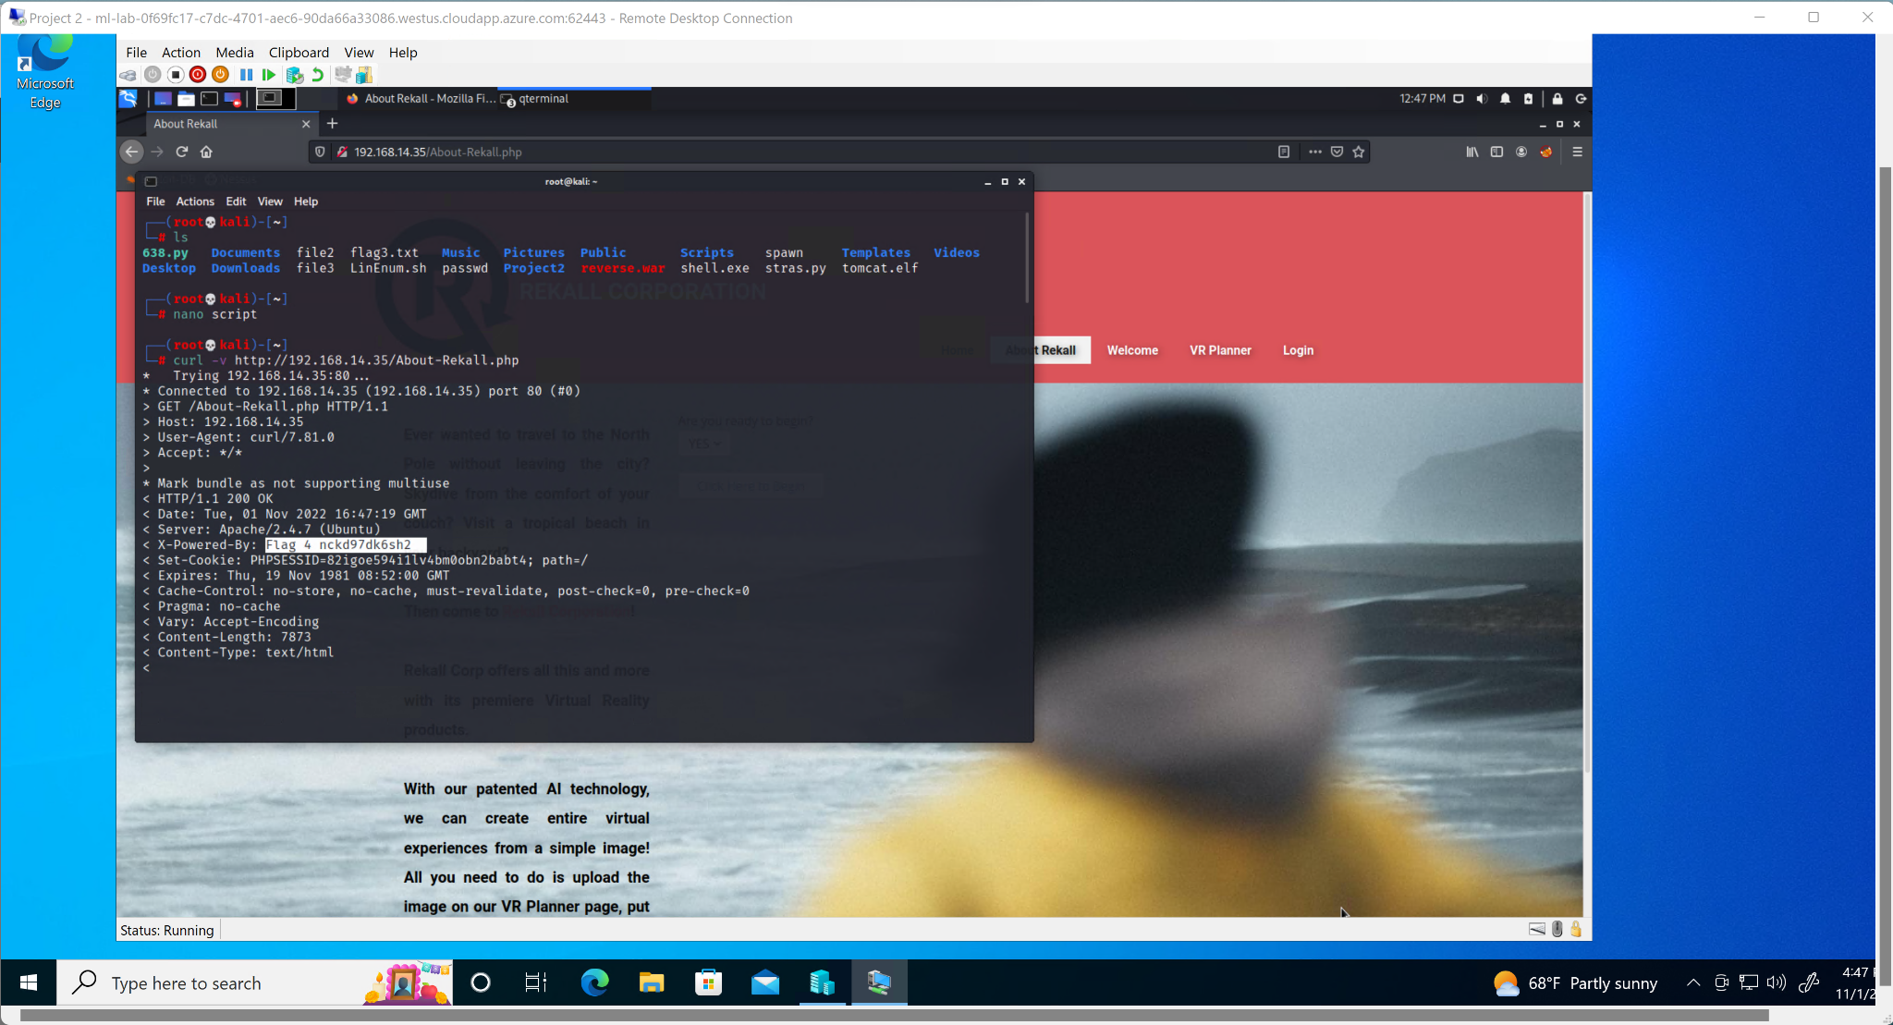

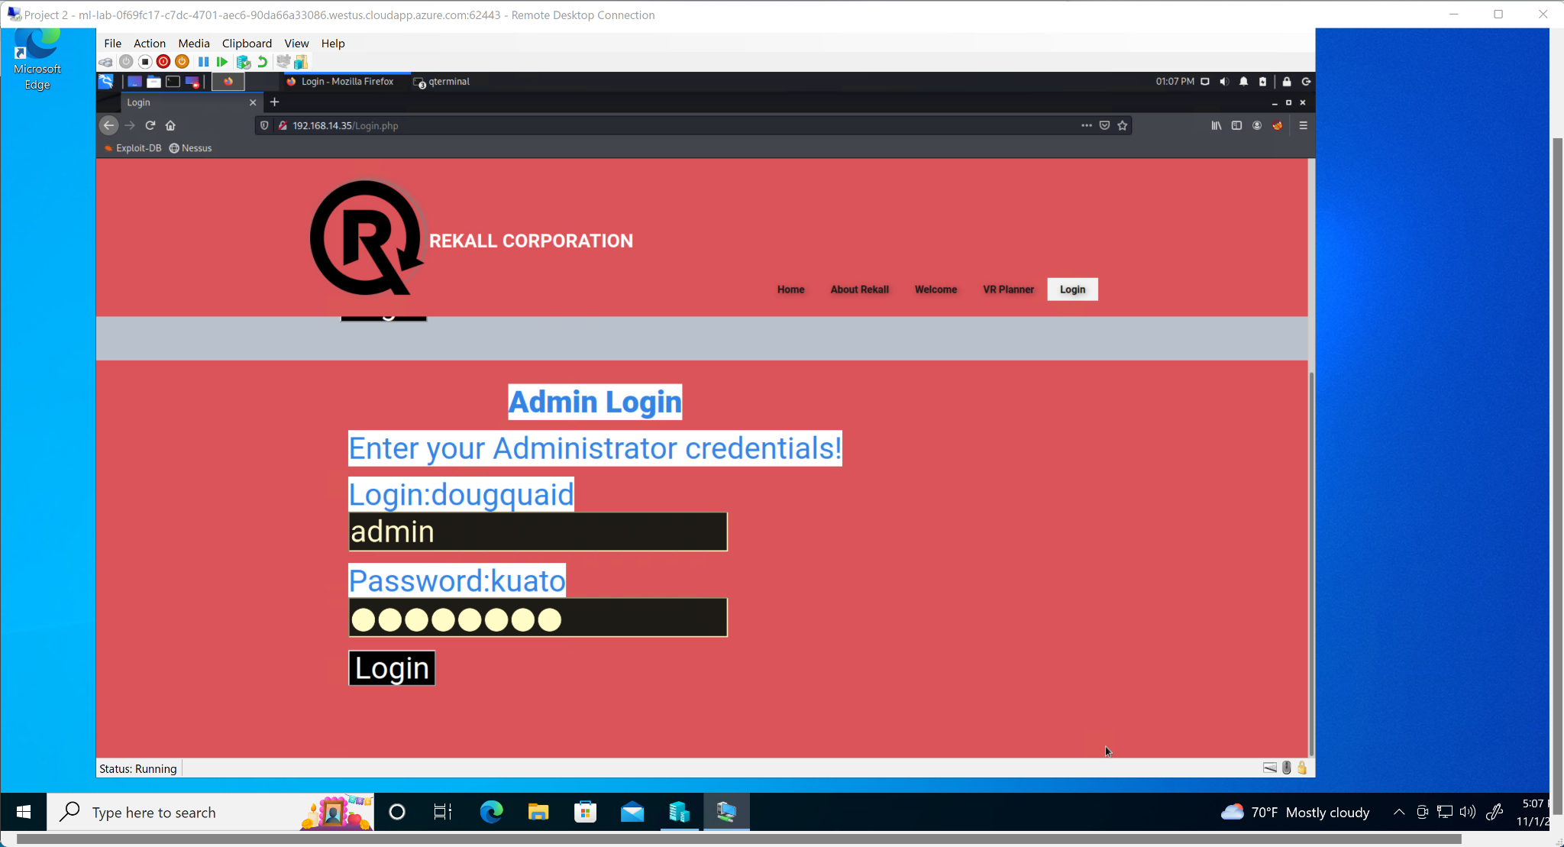

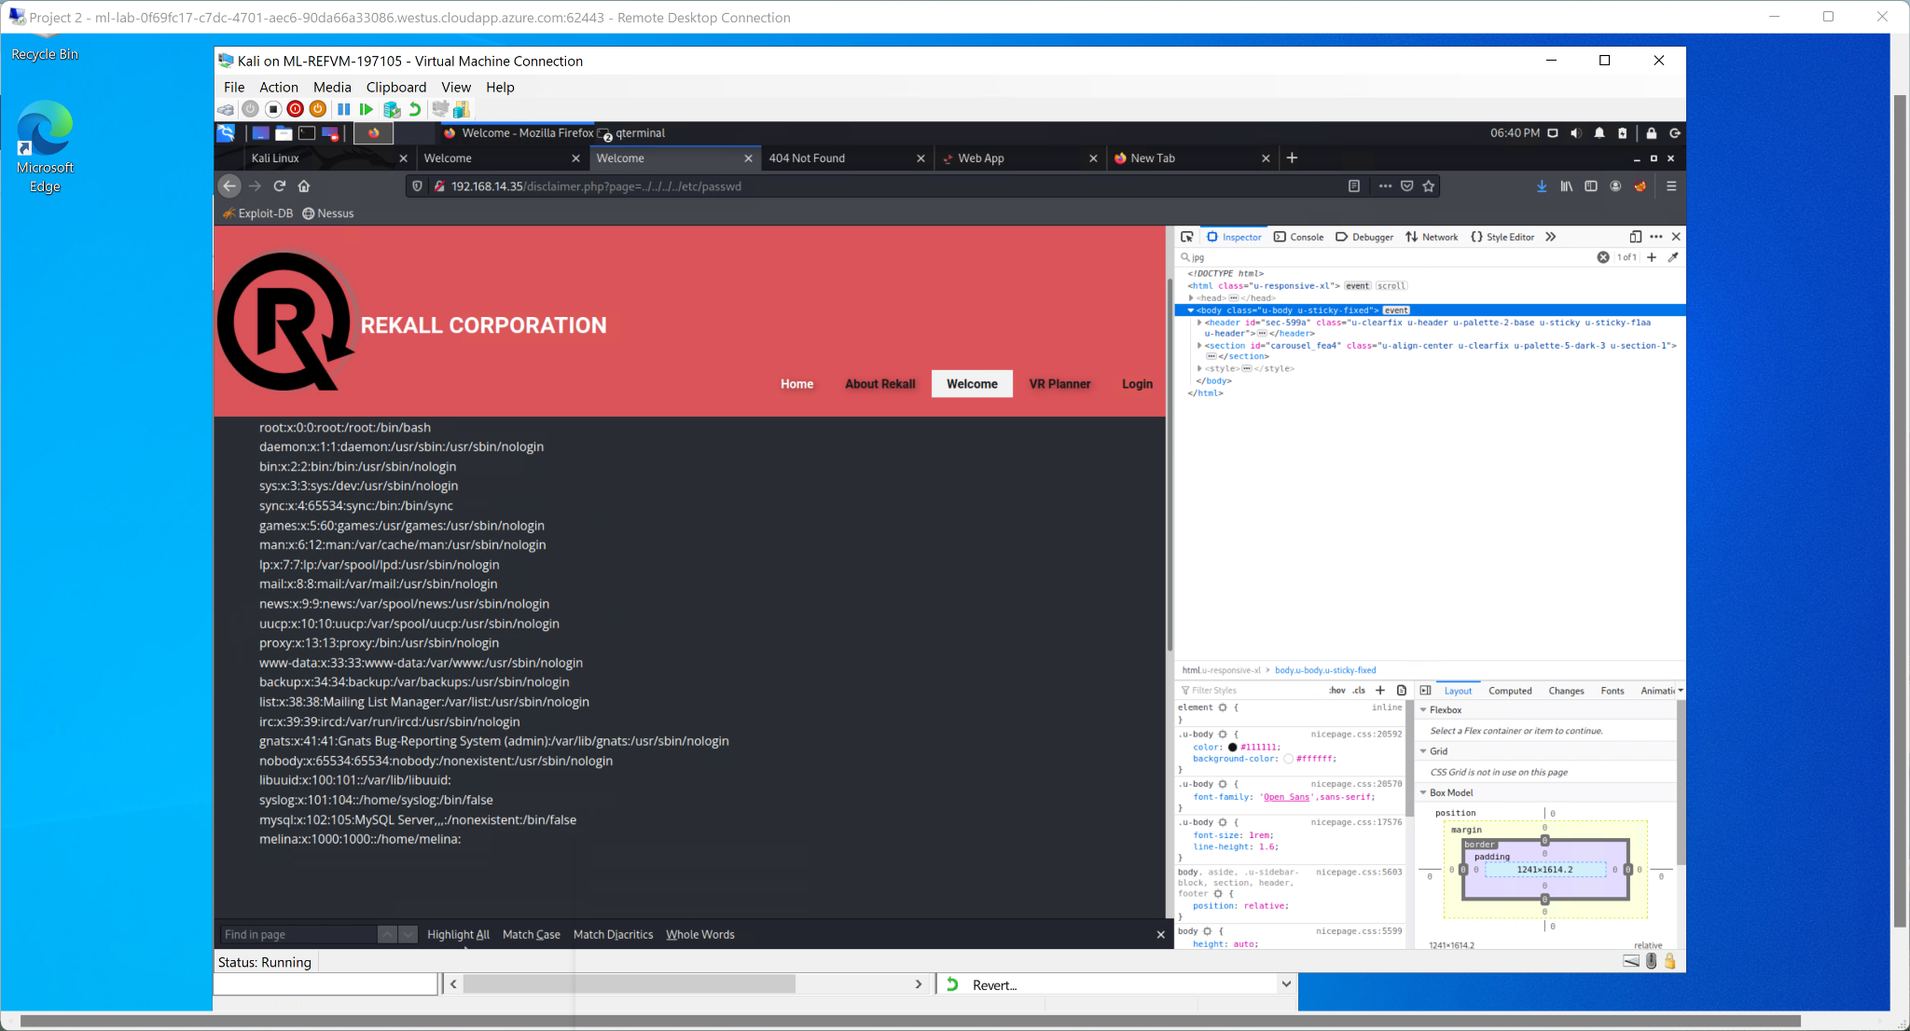

The team performed open-source searches on osinframework.com and Nessus essentials to reveal SSH username, IP addresses, ports, and vulnerabilities such as the Common Vulnerabilities and Exposures (CVE). Active scanning of the network was performed using Nmap to uncover open ports and identify vulnerabilities. The team exploited the Apache Tomcat Remote Code Execution (RCE) vulnerability to gain root access to the server, and used the Metasploit framework to execute the Shellshock vulnerability, allowing unauthorized remote connection to the Bash environment. The Apache Struts vulnerability was also exploited to perform remote code execution on the server. On another server, the Drupal Core RCE vulnerability was exploited to gain access to the host. The team was able to escalate privileges using a sudo security bypass to execute commands as the root user.

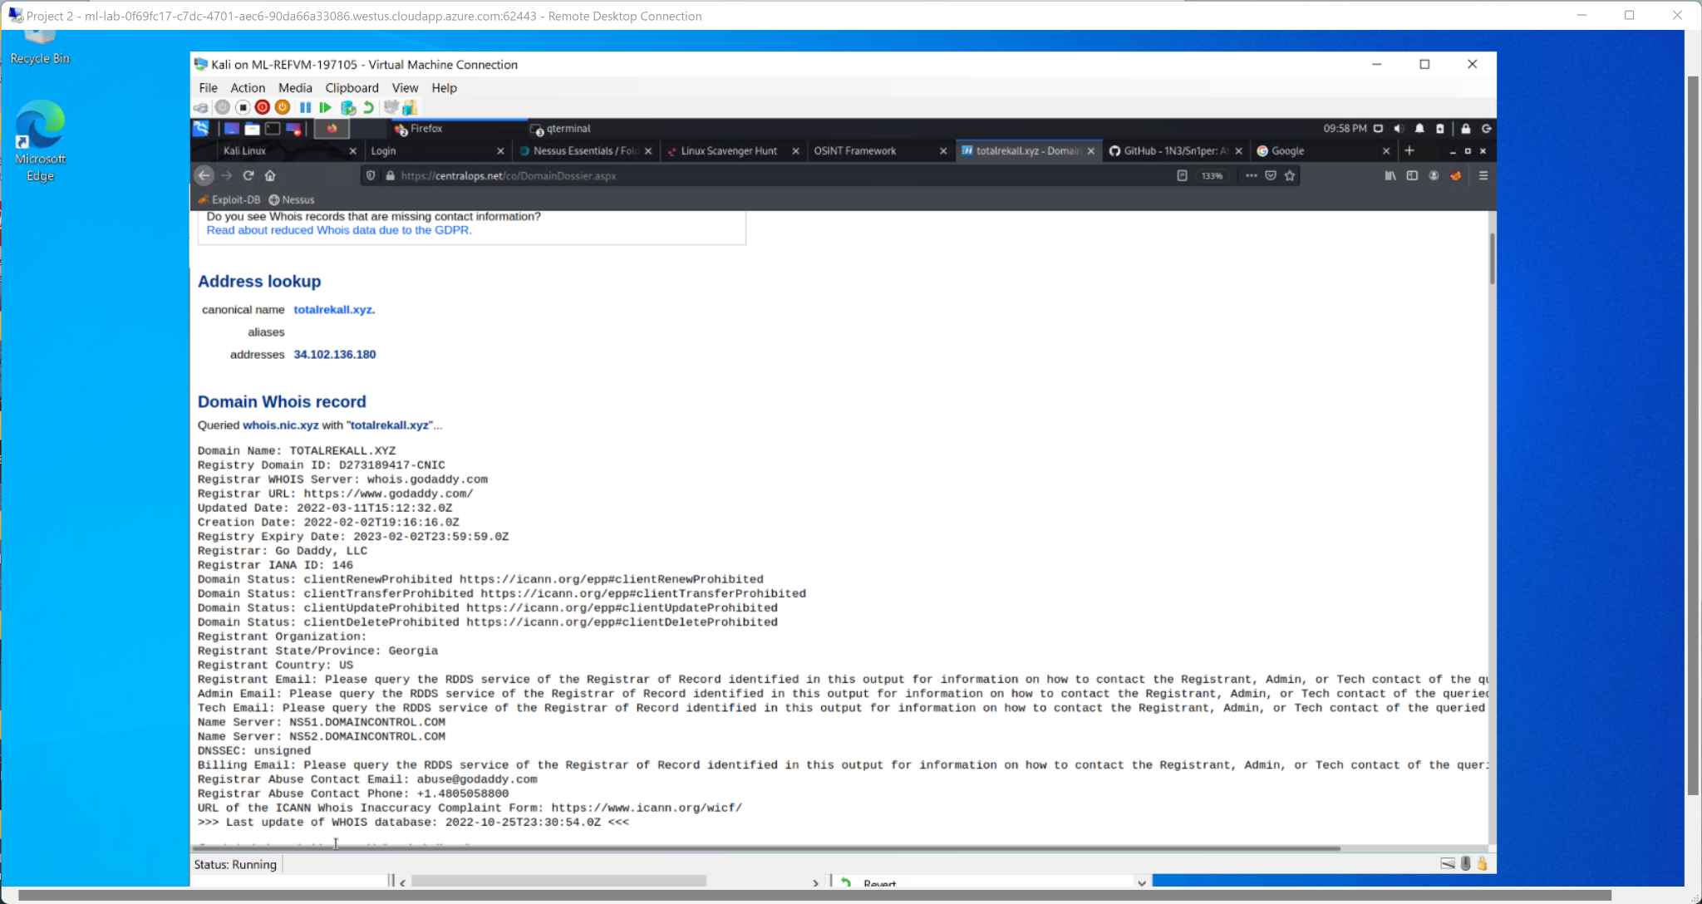

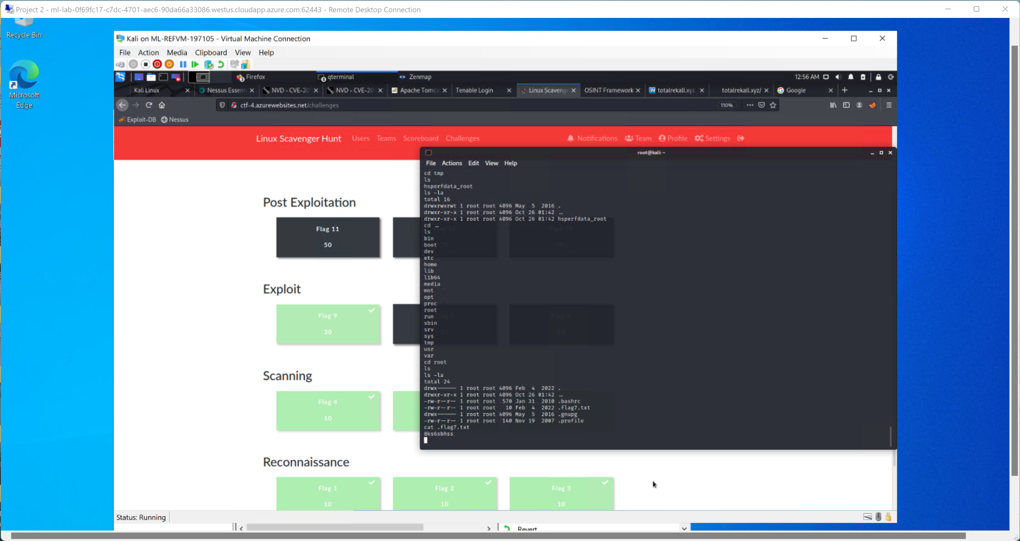

During a recent open-source search, it was discovered that the user name and password for the Rekall GitHub repository were exposed. This allowed login to the web portal and access to hidden files. Through HTTP and FTP enumeration, it was possible to gain remote access to the server through unsecure FTP open ports using anonymous login. The SLMail vulnerability was then exploited through open port 110, resulting in a successful Meterpreter session and the ability to perform a hash dump of password hashes. This enabled lateral movement onto additional servers and the escalation of privileges to administrative users, creating a persistent threat to the Rekall servers.

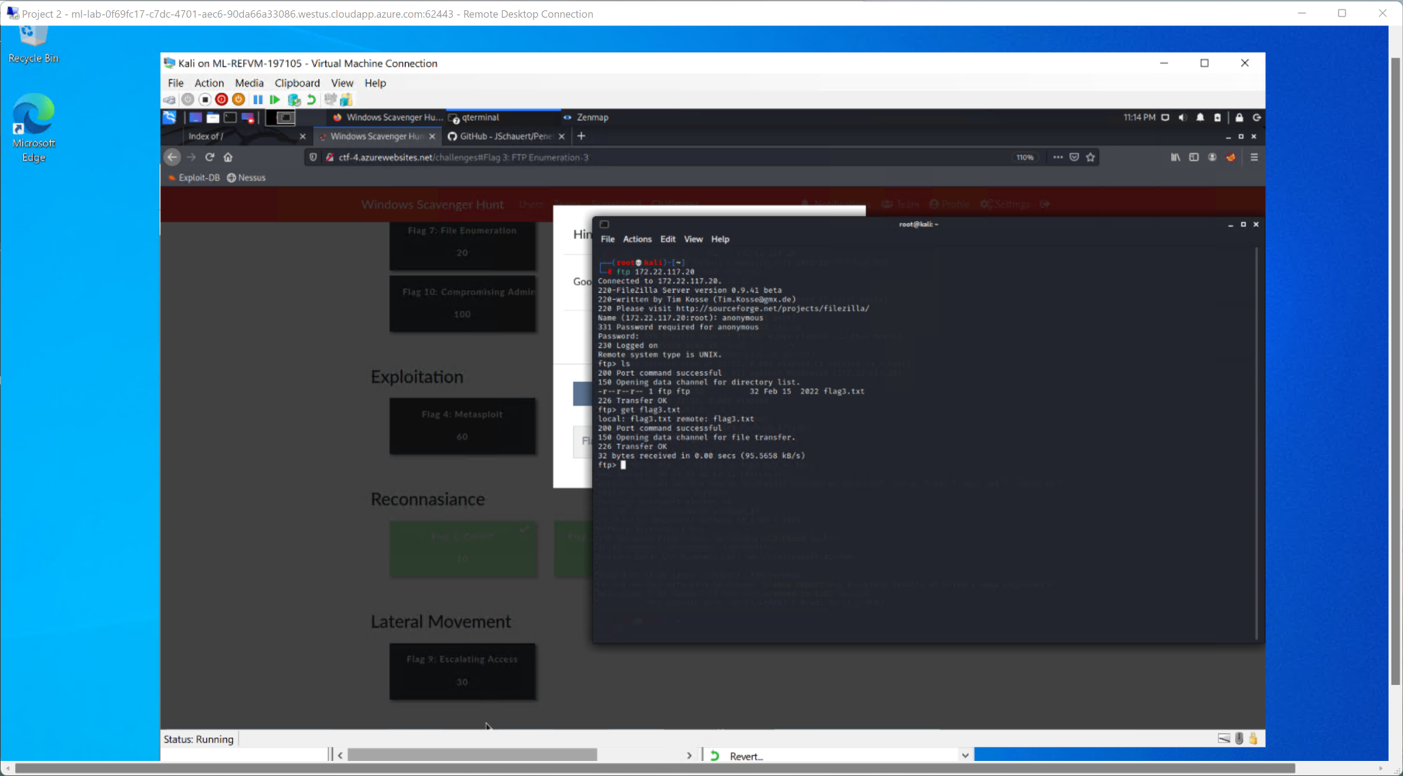

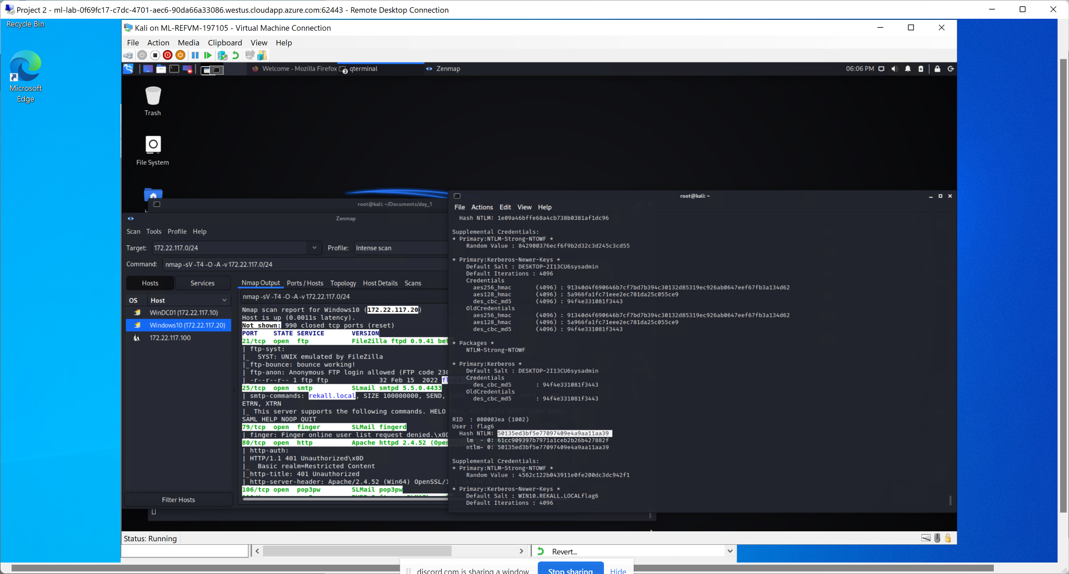

The penetration testing of the Rekall network infrastructure revealed an unsatisfactory security posture, highlighting the vulnerability of the company's current network. This assessment will allow Rekall to identify and correct deficiencies, upgrading to a stronger cybersecurity posture.

## 

## 

## Summary Vulnerability Overview

|  |  |
| --- | --- |
| **Vulnerability** | **Severity** |
| 1. XSS Reflected | **High** |
| 1. XSS Reflected (Advanced) | **High** |
| 1. XSS Stored | **High** |
| 1. Sensitive data exposure (x2) | **Low** |
| 1. Locale File Inclusion | **Critical** |
| 1. Locale File Inclusion (Advanced) | **Critical** |
| 1. SQL Injection | **Critical** |
| 1. Sensitive data exposure (Robots.txt) | **Low** |
| 1. Command Injection | **Critical** |
| 1. Command Injection (Advanced) | **Critical** |
| 1. Brute Force Attack | **Critical** |
| 1. PHP Injection | **Critical** |
| 1. Session Management - | **Critical** |
| 1. Directory Traversal | **Critical** |
| 1. Apache Tomcat JSP Upload bypass RCE (CVE-2017-12617) | **Critical** |
| 1. Shellshock (CVE-2014-6271) | **Critical** |
| 1. Apache Struts Jakarta Multipart Parser OGNL Injection (Metasploit) (CVE-2017-5638) | **Critical** |
| 1. Drupal Core RCE (CVE-2019-6340) | **High** |
| 1. Sudo 1.8.27 – Security Bypass (CVE-2019-14287) | **High** |
| 1. Anonymous FTP Vulnerability (CVE-1999-0497) | **Information** |
| 1. Seattle Lab Mail (SLmail) 5.5 - POP3 'PASS' Remote Buffer Overflow (CVE-2003-0264) | **Critical** |

The following summary tables represent an overview of the assessment findings for this penetration test:

|  |  |
| --- | --- |
| **Scan Type** | **Total** |
| Hosts | 1. 192.168.14.35  2. 172.22.117.20  3. 172.22.117.10  4. 192.168.13.10  5. 192.168.13.11  6. 192.168.13.12  7. 192.168.13.13  8. 192.168.13.14 |
| Ports | 1. 21  2. 22  3. 80  4. 106  5. 110 |

|  |  |
| --- | --- |
| **Exploitation Risk** | **Total** |
| **Critical** | 13 |
| **High** | 5 |
| **Medium** | 0 |
| **Low** | 2 |

## Vulnerability Findings

|  |  |
| --- | --- |
| **Vulnerability 1** | **Findings** |
| **Title** | XSS Reflected |
| **Type (Web app / Linux OS / WIndows OS)** | Web app |
| **Risk Rating** | High |
| **Description** | A malicious script has been injected into the home page. The script is as follows:  <script>alert("Hi Robert")</script> |
| **Images** |  |
| **Affected Hosts** | 192.168.14.35 |
| **Remediation** | Input Validation |

|  |  |
| --- | --- |
| **Vulnerability 2** | **Findings** |
| **Title** | XSS Reflected (Advanced) |
| **Type (Web app / Linux OS / WIndows OS)** | Web app |
| **Risk Rating** | High |
| **Description** | An advanced cross-site scripting (XSS) attack was detected that bypassed input validation parameters. A malicious script was injected into the Memory-Planner page. The script is as follows:  Script: <SCRIPscriptT>alert(“hi”)</SCRIPscripTt>. |
| **Images** |  |
| **Affected Hosts** | 192.168.14.35 |
| **Remediation** | Sanitize data and Content Security Policy |

|  |  |
| --- | --- |
| **Vulnerability 3** | **Findings** |
| **Title** | XSS Stored |
| **Type (Web app / Linux OS / WIndows OS)** | Web App |
| **Risk Rating** | High |
| **Description** | A stored cross-site scripting attack was detected in which a malicious script was submitted to the Comment page. The script is as follows: <script>alert(1)</script> |
| **Images** |  |
| **Affected Hosts** | 192.168.14.35 |
| **Remediation** | Validate user inputs |

|  |  |
| --- | --- |
| **Vulnerability 4** | **Findings** |
| **Title** | Sensitive data exposure |
| **Type (Web app / Linux OS / WIndows OS)** | Web app |
| **Risk Rating** | Low |
| **Description** | Sensitive data exposure in the HTTP response header |
| **Images** |  |
| **Affected Hosts** | 192.168.14.35 |
| **Remediation** | Use SSL and have HTTPS security on web pages that store information. |

|  |  |
| --- | --- |
| **Vulnerability 5** | **Findings** |
| **Title** | Locale File Inclusion |
| **Type (Web app / Linux OS / WIndows OS)** | Web app |
| **Risk Rating** | Critical |
| **Description** | A local file inclusion (LFI) attack was detected in which a .php file was uploaded to the Memory-Planner page via the upload tab. The file was successfully uploaded. |
| **Images** |  |
| **Affected Hosts** | 192.168.14.35 |
| **Remediation** | Prevent users from passing input into the file systems and framework API. |

|  |  |
| --- | --- |
| **Vulnerability 6** | **Findings** |
| **Title** | Local File Inclusion (advanced) |
| **Type (Web app / Linux OS / WIndows OS)** | Web app |
| **Risk Rating** | Critical |
| **Description** | An advanced local file inclusion attack was detected in which a .php file was encoded as a .jpg and successfully uploaded through the image upload tab on the Memory-Planner page. This allowed the attacker to bypass input validation checks. |
| **Images** |  |
| **Affected Hosts** | 192.168.14.35 |
| **Remediation** | To prevent malicious input from being passed into the file systems and framework API, it is recommended to limit the API to only allowing the inclusion of files from one trusted directory. Any requests containing invalid characters should also be rejected. This will help to protect the system from potential attacks and maintain the security and integrity of the system. |

|  |  |
| --- | --- |
| **Vulnerability 7** | **Findings** |
| **Title** | SQL injection |
| **Type (Web app / Linux OS / WIndows OS)** | Web app |
| **Risk Rating** | critical |
| **Description** | A SQL injection attack was detected in the password field of the login page. The payload used was: '0' or '0'='0' |
| **Images** |  |
| **Affected Hosts** | 192.168.14.35 |
| **Remediation** | Use parameterized queries |

|  |  |
| --- | --- |
| **Vulnerability 8(x2)** | **Findings** |
| **Title** | Sensitive data exposure |
| **Type (Web app / Linux OS / WIndows OS)** | Web app |
| **Risk Rating** | Low |
| **Description** | It was discovered that the username and password for the website or application are stored in the HTML code and are potentially visible when the webpage is highlighted. This presents a security vulnerability as it allows anyone with access to the HTML code to view the login credentials and potentially gain unauthorized access to the system. |
| **Images** |  |
| **Affected Hosts** | 192.168.14.35 |
| **Remediation** | To address this issue, it is important to store sensitive information, such as passwords, in a secure location and not in the HTML code. There are various methods for securely storing and handling passwords, such as using hashing and salting techniques, and storing the passwords in a separate database or configuration file. It is also important to ensure that the website or application has proper access controls in place to prevent unauthorized access. |